Additional Q1

<!DOCTYPE html>
<html lang="en">
<head>
<meta charset="UTF-8">
<meta name="viewport" content="width=device-width, initial-scale=1.0">
<title>Bouncing Ball</title>
<script src="https://code.jquery.com/jquery-3.6.0.min.js"></script>
<style>
body {
display: flex;
justify-content: center;
align-items: center;
height: 100vh;
margin: 0;
background-color: #f0f0f0;
}
#container {
position: relative;
width: 300px;
height: 300px;
background-color: #ccc;
overflow: hidden;
}
#ball {
position: absolute;
width: 50px;
height: 50px;
background-color: red;
border-radius: 50%;
}
</style>
</head>
<body>

<div id="container">
<div id="ball"></div>
</div>

<script>
$(document).ready(function() {
let ball = $('#ball');
let container = $('#container');
let containerWidth = container.width();
let containerHeight = container.height();
let ballWidth = ball.width();
let ballHeight = ball.height();

let xPos = 100;
let yPos = 0;
let xSpeed = 5;
let ySpeed = 5;

function animateBall() {
xPos += xSpeed;
yPos += ySpeed;

if (xPos + ballWidth > containerWidth || xPos < 0) {
xSpeed = -xSpeed;
}
if (yPos + ballHeight > containerHeight || yPos < 0) {
ySpeed = -ySpeed;
}

ball.animate({ left: xPos, top: yPos }, 10, 'linear', animateBall);
}

animateBall();
});
</script>

</body>
</html>

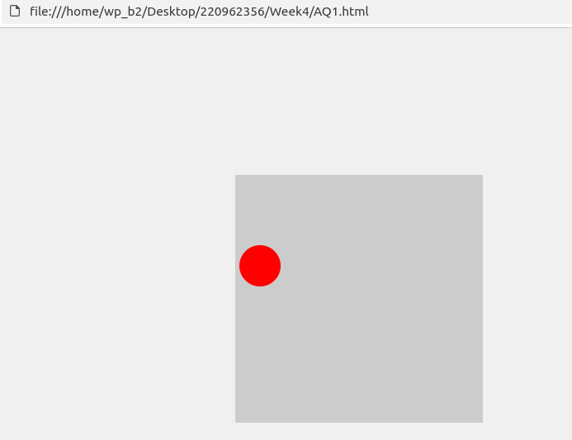
Additional Q2

<!DOCTYPE html>
<html lang="en">
<head>
<meta charset="UTF-8">
<meta name="viewport" content="width=device-width, initial-scale=1.0">
<title>Sliding Text on Image</title>
<script src="https://code.jquery.com/jquery-3.6.0.min.js"></script>
<style>
body {
margin: 0;
padding: 0;
display: flex;
justify-content: center;
align-items: center;
height: 100vh;
background-color: #f0f0f0;
}
.image-container {
position: relative;
width: 600px;
height: 400px;
background-image: url('https://via.placeholder.com/600x400');
background-size: cover;
background-position: center;
}
.sliding-text {
position: absolute;
bottom: 50px;
left: -100%;
font-size: 24px;
color: white;
background-color: rgba(0, 0, 0, 0.5);
padding: 10px;
}
</style>
</head>
<body>

<div class="image-container">
<div class="sliding-text">This is some sliding text on the image!</div>
</div>

<script>
$(document).ready(function() {
function slideText() {
$('.sliding-text').animate({ left: '100%' }, 5000, 'linear', function() {
$(this).css('left', '-100%');
slideText();
});
}

slideText();
});
</script>

</body>
</html>

